 |  | GLSA Soccer Complex
 |  | Greater Libertyville Soccer Association
CLIENT  Greater Libertyville Soccer Association  LOCATION  Libertyville, IL  PROJECT FEATURES  Access Improvements  Parking  Stormwater Management  Synthetic Turf  SCOPE OF SERVICES  Topographic Survey  Preliminary Design  Final Engineering  Stormwater Improvements  Construction Observation  COST  $1.7 Million  REFERENCE  XXX  Title  Lake County Forest Preserve District  19808 W. Grand Avenue  Lake Villa, IL 60046  847.968.3407 |  |  |  | 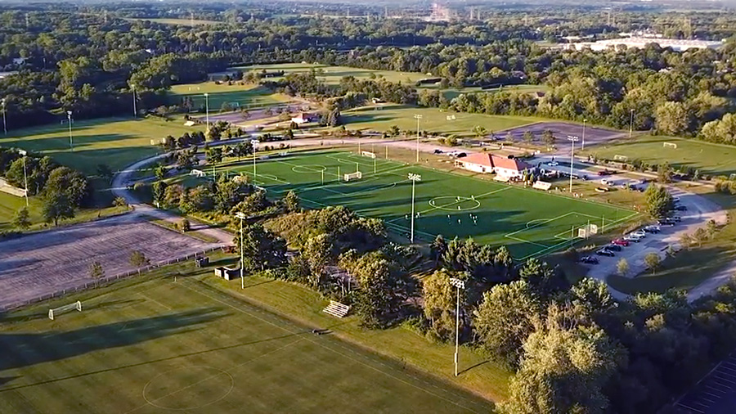
PROJECT OVERVIEW
Gewalt Hamilton Associates, Inc. (GHA) provided civil engineering services for the Lake County Forest Preserve District’s Operations and Public Safety Center, located in the Fourth Lake Forest Preserve, just south of the Village of Lindenhurst, Illinois. The project included construction of a 100,000-square-foot public safety facility, a 180-space parking lot, fuel and material storage facilities, and widening improvements for access onto IL Route 132.
GHA engineered an extensive system of bio-swales, settling pools,
and wetland plantings into the design of the site’s stormwater management system. This was done meet and exceed the requirements of the Lake County Watershed Development Ordinance and the objectives of the Lake County Forest Preserve District.
Permits were obtained from:
- Village of Lindenhurst
- Lake County Stormwater Management Commission (LCSMC)
Stormwater and Wetland
- Illinois Department of Transportation (IDOT)
A portion of the site was intended to remain a natural forest preserve with significant ecological amenities, including high quality wetlands, mature forested areas, and native prairie grasses. An extensive, engineered system of bio-swales, settling pools, and wetland plantings were incorporated into the design of the site’s stormwater management system to satisfy the requirements of the Lake County Watershed Development Ordinance and the objectives of the Lake County Forest Preserve District

